NAME: EKENG, AKANINYENE IME
COURSE: SECURITY OPERATIONS CENTER (SOC) FUNDAMENTALS ON LETSDEFEND
COHORT: NOVARA 28 NOVERMBER 2025
DATE:18/02/2026

AIM: To build foundational knowledge and awareness so beginners can understand SOC operations, start thinking like a SOC analyst, and prepare for more advanced hands on blue team training on the platform (like simulated incident investigations in a virtual SOC environment).

INTRODUCTION

A Security Operations Center (SOC) is a centralized unit within an organization responsible for monitoring, detecting, analyzing, and responding to cybersecurity incidents in real time. The SOC plays a vital role in protecting an organization’s IT infrastructure by using people, processes, and technologies to defend against threats such as malware, unauthorized access, and data breaches.
At its core, a SOC continuously collects data from various sources servers, endpoints, network devices, and applications and uses tools like Security Information and Event Management (SIEM), Endpoint Detection and Response (EDR), and log management systems to analyze this data. SOC analysts are typically categorized into different tiers (e.g., Tier 1 for initial alert triage, Tier 2 for deeper investigation, Tier 3 for advanced analysis), and they follow structured processes to investigate and respond to security events.

MATERIALS
- LetsDefend.io Platform
- SIEM Simulator
- Log Data / Alerts
- Endpoint Logs
- Threat Intelligence Data

PROCEDURES

- I login to LetsDefend.io and start the SOC Fundamentals course.
- I navigated to the Introduction to SOC lesson module.
- I read/watched the theory segment explaining what an SOC is and why it’s important.
- I explored the basic SOC tools and dashboards presented in the platform.
- I accessed the simulated logs or alerts for analysis.
- I performed basic alert triage like:
- Review alert details.
- Determine whether an alert is benign or suspicious.
- Log initial observations.
- I used simulated data to analyze a potential security incident and classify it.
- I documented the investigation process for each alert:
- Source of alert (e.g., SIEM, endpoint)
- Type of event
- Investigation steps
- Outcome

OBSERVATION
- I observed that, majority of alerts are false positives requiring triage.
- I observed that, valuable context often comes from correlated data sources.
- I observed that, communication with team members is essential in complex investigations.
- I observed that, correlated logs help detect patterns indicating suspicious activity.

PRECAUTIONS
When using a SOC training platform:
- I ensured that, i do not use real production data in the training environment.
- I ensured that, i always follow the training platform’s terms of use and professional codes of conduct.
- I ensured that, i maintain confidentiality when documenting sensitive details.
- I ensured that, i verify that your training environment (e.g., simulated SIEM) is isolated from real corporate networks.
- I ensured that, i confirm your understanding of alert labels and classifications before taking action.
- I ensured that, i document all investigative steps clearly avoid assumptions without data.

CONCLUSION
The Introduction to SOC lesson provides foundational knowledge about how a Security Operations Center functions within a defensive cybersecurity role. By combining theory with simulated hands on practice, learners understand key processes such as monitoring, alert triage, and incident investigation. The SOC environment emphasizes analytical thinking, understanding security tools like SIEM, and consistently documenting actions taken during investigations. This lesson paves the way for more advanced SOC skills, such as threat hunting, incident response, and log analysis.
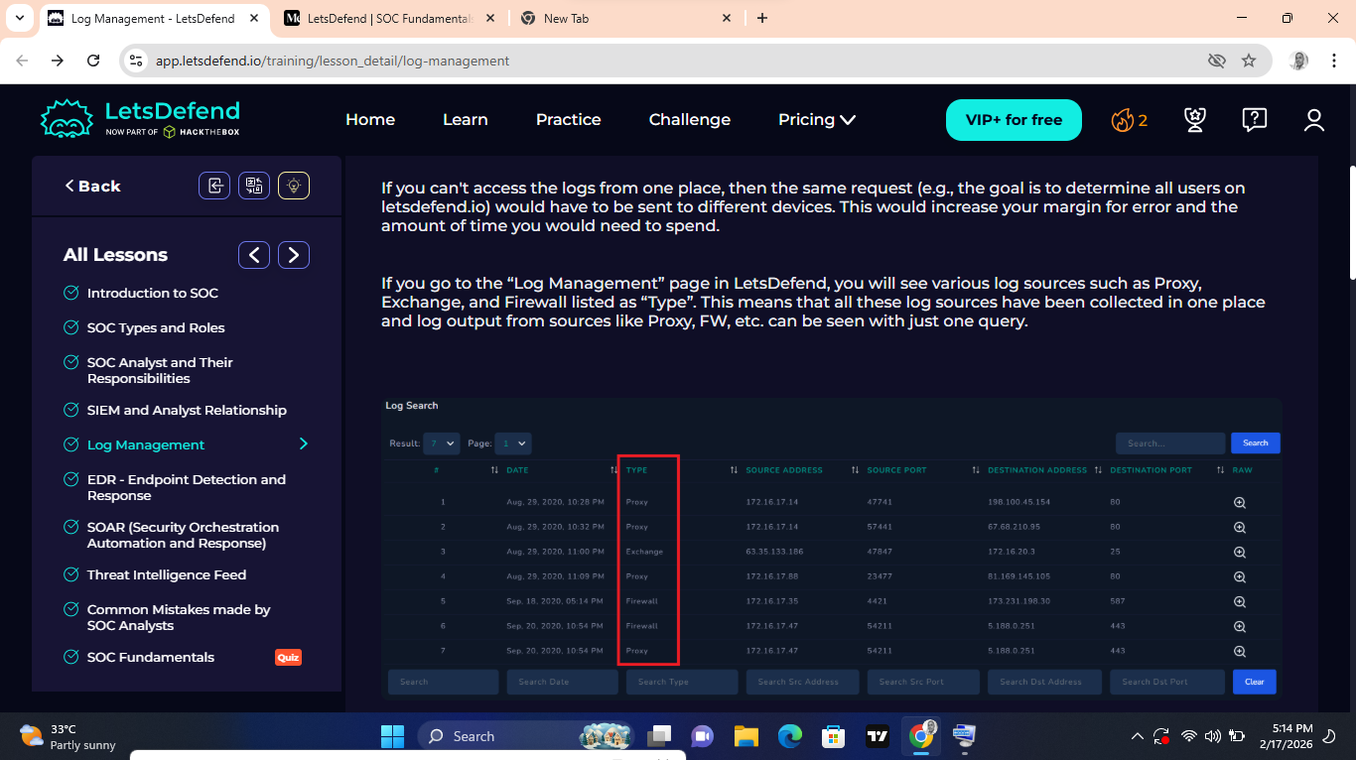

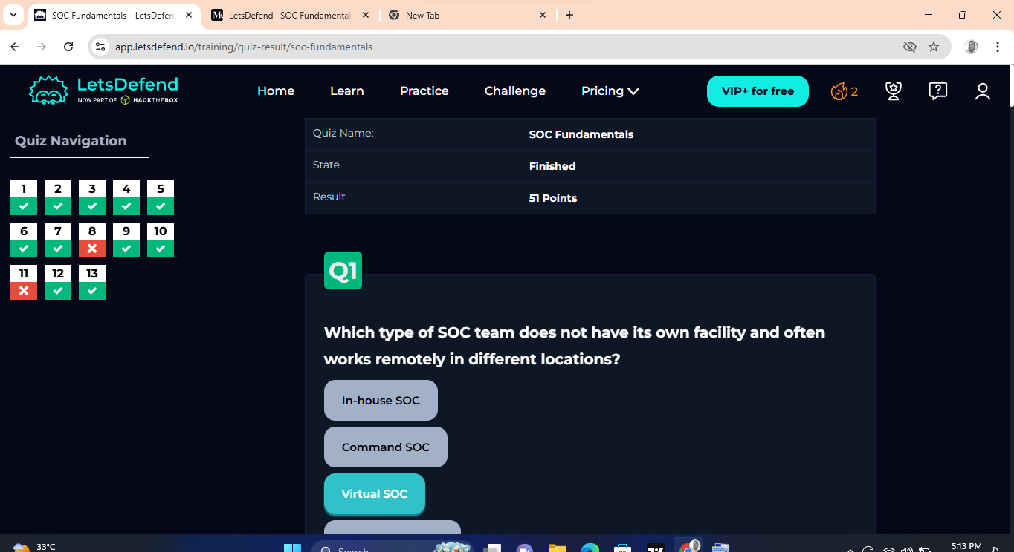
SCREENSHOT OF MY SUCCESSFUL COMPLETION.

